[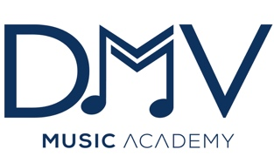](https://www.dmvmusicacademy.org/)

Presents:

[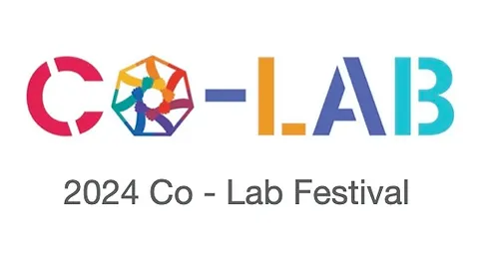](https://www.dmvmusicacademy.org/co-labfestival)

***DMV Brass & Winds Academy***

***July 22nd – 24th 2024***

[*Washington Adventist University*](https://www.waumusic.org/winds)

[***​***](https://www.waumusic.org/winds)

***Our Brass & Winds Academies will feature professional brass and winds artists throughout the DMV region, including:***

[Cheryl Nkeba](https://www.dmvmusicacademy.org/staff), Director, DMV Winds Academy

[*Lyric Brass Quintet*](https://larrywilliamsus.wixsite.com/lyricbrass)

[*Quintessential Wind Quintet*](https://www.dmvmusicacademy.org/residentensembles)

[*WAU Brass & Winds faculty*](https://www.waumusic.org/)

[Anthony Townes](https://www.dmvpercussion.org/about-the-host), Director of Bands, Northwestern High School

[Kyle Pompei,](https://kylepompeihorn.com/bio) Brass and Winds Clinician

***Students will participate in:***

Masterclasses, Chamber Ensembles, and Performances, Daily Mindfulness Meditation Practice

***Our Mission***

*DMV Music Academy offers excellent music education, performance, professional development, and enrichment programs to all residents of the DMV Region.*

***Our Vision***

*To use the transformative power of music to connect, enrich lives, and shift the artistic landscape to foster a culture of inclusion and social justice.*

**2024 CO-LAB FESTIVAL SPONSORSHIP LEVELS & BENEFITS**

**DMVMA Visionary Level: $10,000+**

- Corporate Visibility and Media Exposure

- DMVMA apparel

- Special Sponsorship Recognition at the Final Concert

- Company name/logo included on collateral, including print and online advertising

- Logo Inclusion on DMVMA website

- Reserved Seating for all events

- Private Meet & Greet Opportunities with festival artists and clinicians!

**DMVMA Creator Level: $5,000**

- Company name/logo included on collateral, including print and online advertising

- Special Sponsorship Recognition at the Final Concert

- Logo Inclusion on DMVMA website

- Four Reserved Seats for the Final Concert

**DMVMA Collaborator Sponsor: $2,500**

- Corporate Visibility and Media Exposure

- Company name/logo included on collateral, including print and online advertising

Whether you are an individual, business, corporation, or other community partner, your support is critical to our ability to offer world-class music instruction, professional development for music educators, and enrichment programs to residents of the DMV Region.

Make checks payable to:

DMV Music Academy

4111 Nicholson Street, Suite # 4

Hyattsville, MD 20782

DMV Music Academy is a registered 501(c)(3) non-profit organization. EIN #84-3095247. (202) 553-4885 | [contact@dmvmusicacademy.org](mailto:contact@dmvmusicacademy.org) | [www.dmvmusicacademy.org](http://www.dmvmusicacademy.org)

